Scotland Innovates

Triage & Assessment Process

Contents
Scotland Innovates Triage & Assessment Process 3
Non Health Pre-Project Phase 7
Health Process 8
Triage & Assessment Documents 9

Scotland Innovates Triage & Assessment Process

- Innovator submits their innovation via Scotland Innovates. Dependant on selected Sector, the submission is displayed on the relevant Admin(s) worklist as “Submitted (Initial)” status.

- The relevant Admin (Health, Non Health or both) completes various due diligence activities, such as a company credit check, investigating existing frameworks and/or looking into upcoming procurement processes. The Scotland Innovates system will allow an Admin to close a submission at any point in the process. If the submission is definitely not innovative it may be closed at this stage and feedback will be given to the Innovator. If the submission does appear to be innovative then a meeting will be arranged with the Innovator to discuss further.

- A teams meeting will be held where the Admin(s) will provide further information about the Scotland Innovates process and opportunities within the public sector. The Admin will ask the Innovator to submit any missing detail from their submission via the Request Information function. Once the Innovator has updated their submission and resubmitted the innovation will be shown as “Submitted (Resubmitted)” status on the Admin worklist. If the Admin is happy with the information provided they will select “Complete Submission” on the system and the status will change to “Submitted (Final)”. The submission will no longer be editable.

- Once the final submission has been made the Admin will generate the submission report which pulls together all information from the Innovator and information recorded by the Admin. For Non Health innovations these reports will be shared with the Triage and Delivery Board for initial review. For Health innovations submission reports will be sent to Assessors via appropriate agreed routes.

- The Triage and Delivery Board will meet on a regular basis, fortnightly or monthly, dependant on submission volumes. At these meetings the Board will review submissions made during the preceding period and make a decision on whether they should be taken forward for full assessment. If the Board decide not to take the submission forward to assessment then the submission will be closed and feedback provided. If the Board do decide to assess then a decision will be made on appropriate sectors for assessment and Triage and Delivery Board members will confirm the Assessors from their own sectors. A Triage form will be completed as a group and the Admin will select the “Complete Triage” button on Scotland Innovates, moving the status to “Triaged”.

- Once Assessors are confirmed their details will be registered on the Scotland Innovates system and the innovation will be assigned to them for assessment. This will allow the Assessor to access the submission report details via the system. Once all Assessors are assigned, the Admin can select “Complete Assignment” to move the status to “Awaiting Assessment”. The Assessors should fully review all information provided to them and consider the submission in relation to their business requirements and priorities. A Solution Assessment form will then be completed by each Assessor which can be uploaded to the system or returned to SPPD via email.

- Once all assessments are completed the Admin can select the “Complete Assessments” button on the Scotland Innovates system. This will change the innovation status to “Assessed” Status.

- All assessment feedback will be collated by the Admin and will be brought back to the Triage and Delivery Board to decide the most appropriate course of action. A decision whether to take the submission to market through an appropriate route will be made by the Board based on the assessment feedback, and available resources. If the Board decide that the submission should not be taken forward at this time then the submission will be closed and feedback provided. If the Board do decide to take the submission to market then a Business Case will be completed and appropriate resources agreed. A project will then commence. The Triage form will be completed in any case.

- We will be able to report on submission date via the Scotland Innovates system and this will be published in a quarterly dashboard. The dashboard will detail the number of initial and finalised submissions, the number being assessed and the number closed within a specified period. Further detailed data will also be made available where requested.

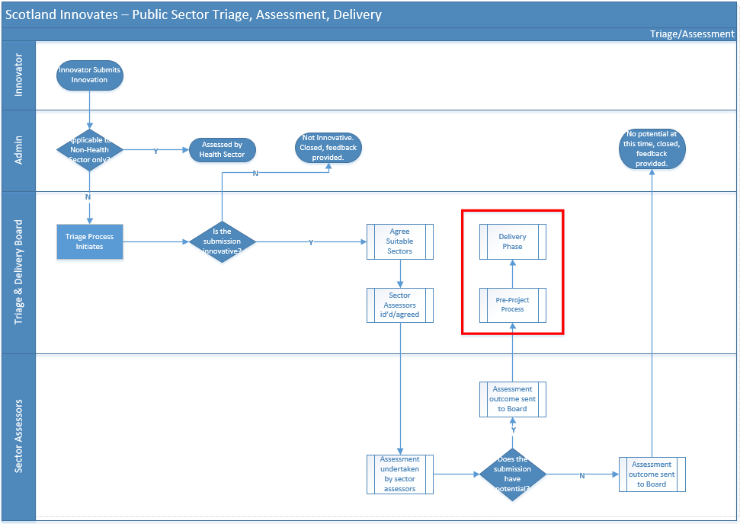

Non Health Pre-Project Phase
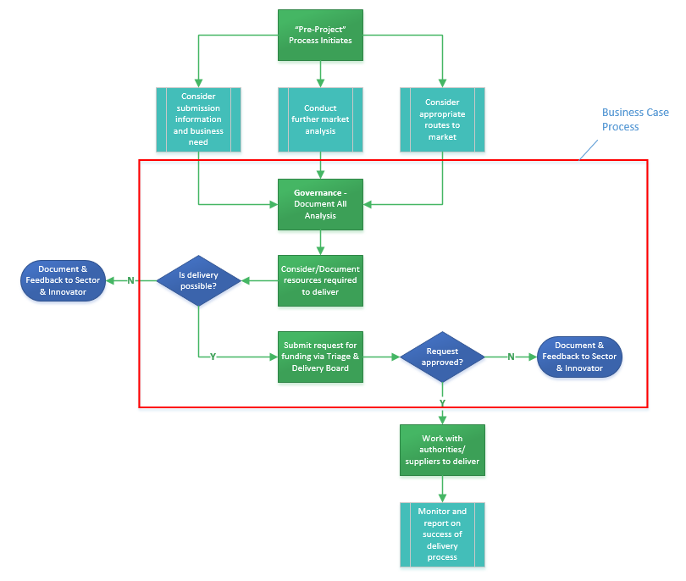

Health Process

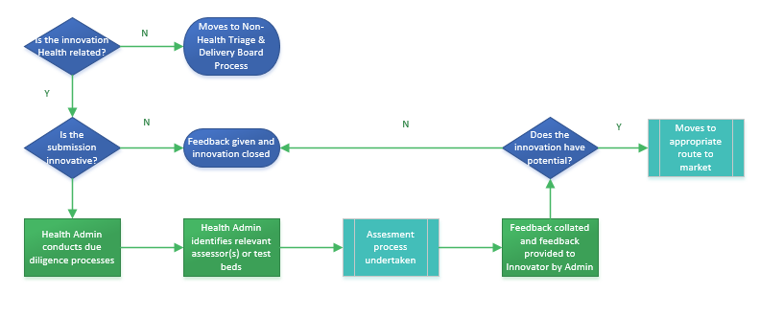

Triage & Assessment Documents

