Scotland Innovates

Registration, Innovation Submission and Assessment Processes

How to register on Scotland Innovates and submit a solution for assessment

Before submitting an innovative solution for assessment, a company or individual must register as an Innovator via the Scotland Innovates website.

In order to register as an Innovator, you must click the Register for a new Account button on the homepage and complete a range of mandatory registration questions such as company name, company address, company size and contact information. All relevant fields must be fully completed.

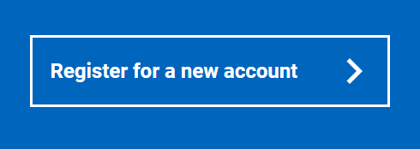

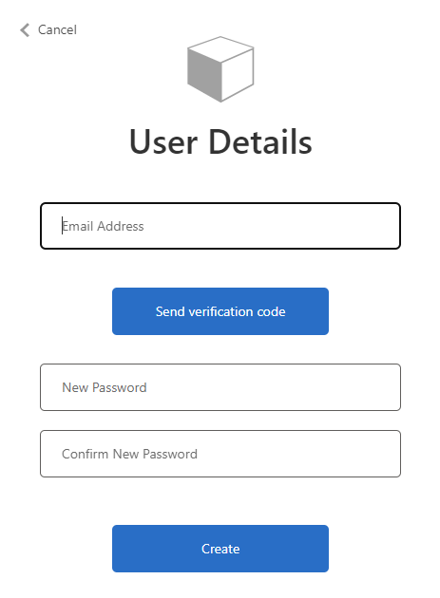

You must verify your email address before the registration process can be completed. Once you enter your email address and click the Send Verification Code button you will receive a validation code by email that must be entered to complete your registration. Enter the code into the verification code field and click Verify Code. You must then add and confirm your new password.

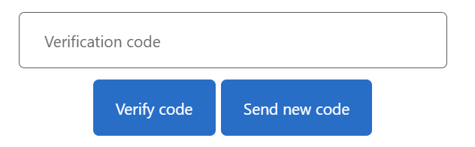

You must then complete your profile, providing your name, contact and organisation details etc.

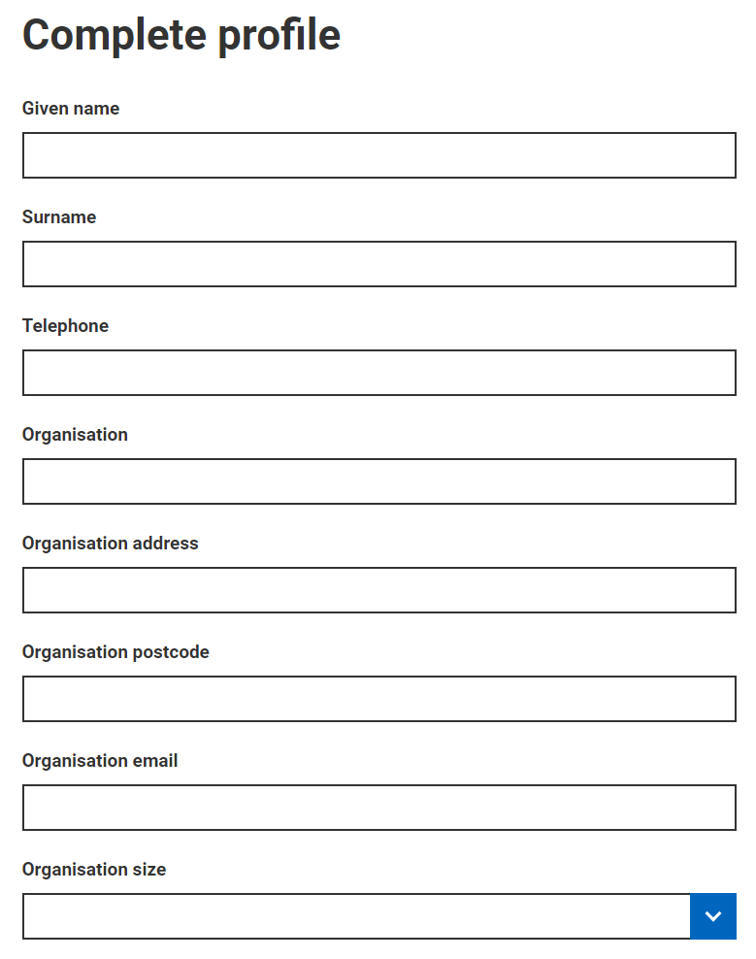

Please note: You must only request to become an Assessor with prior approval from Scotland Innovates Administrators. The Assessor role is only applicable to Public Sector staff, Health Sector staff and other relevant subject matter experts. If you do have approval to register as an Assessor please check the box and select the appropriate organisation sector when completing your registration.

Innovators must not check the Assessor box when registering. All Innovator users must select Other for organisation sector.

Your registered company name will be automatically associated with any innovations submitted via your registered account, therefor if you are acting on behalf of multiple companies you must set up multiple accounts, one for each company with unique email addresses.

To finalise your registration you will have to agree to the Registered User Terms and Conditions. Please read them carefully, to avoid any misunderstanding. Check the box and click Save.

Innovation Submission
Once you have completed the registration process and you are ready to submit your innovative solution you can submit an innovation in two ways: you can select the Submit Your Innovation button on the homepage or the Innovations option at the top of the homepage.

When using the Innovations option click Create an Innovation.

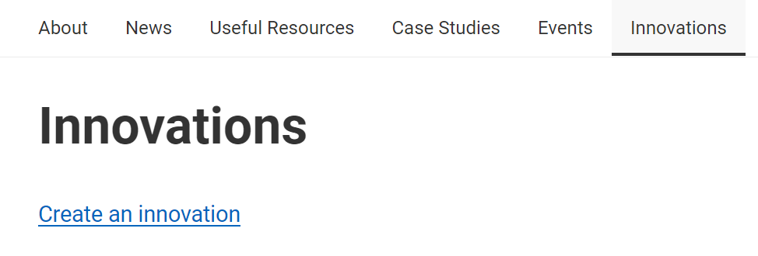
You will have to accept the Registered User Terms and Conditions again prior to solution submission. Check the box and click Save and Continue. These must be accepted before you can move onto the Scotland Innovates Question Set, as detailed below. The company name registered in your account details will automatically be associated with the solution.
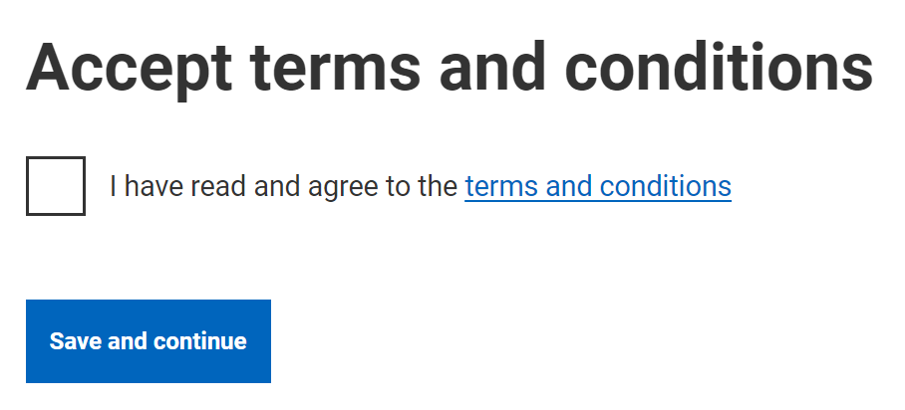

Scotland Innovates Question Set
You will be asked to complete a question set prior to the triage and assessment of your solution. All of these questions are mandatory and must be completed before submission. There is a file upload function for appropriate questions within the question set to facilitate uploading further relevant information. Guidance on each question is available at each question. You should use the save and continue button to move through the question set and you will be able to start, save and complete at a later date, if required. Clicking on the Innovations option on the top toolbar will take you back to your worklist where the innovation will display as draft status until submitted.

Q1: Title

The title of your innovation/solution.

Q2: Description of Solution

You will be required to fully describe your solution in detail using the document upload function where applicable/required. Please explain your solution and how it best fits into the particular infrastructure area you are targeting.

Q3. Sector

You will be required to select one primary sector from the available sector options. Further information on each sector can be found in the Sector and Category Information document within the Useful Resources section.

Your solution may apply to multiple sectors, but to assist us with assessment you should select the primary sector where your solution is likely to bring most benefit.

Please note: Do not submit your innovation more than once in an attempt to ensure more coverage. Through our conversations with you, we will identify if the solution relates to more than one sector or category and assign for assessment accordingly.

Q4: The most relevant category for your solution

You will be required to choose one category from the available options using the smart search functionality. As above, further information on the available categories can be found in the Sector and Category Information document within the Useful Resources section.

Using the smart search functionality please pick the most appropriate business area of discipline category that best fits your solution. Your solution may apply to multiple categories, but to assist us with assessment you should select the primary category where the solution is likely to bring most benefit.

Q5: Key Benefits of Solution

You will be required to detail SMART (Specific, Measurable, Achievable, Realistic, Time-bound) benefits of your submitted solution. These benefits could include, but are not limited to: potential for positive health impacts, improved safety, improved clinical outcomes, improved efficiency or cost-effectiveness, improved sustainability/resilience of the service or any other benefits that would impact service delivery, users and staff.

Q6: Does your solution improve or replace an existing alternative?

Please tell us if your solution replaces an existing alternative. If so, please provide details of the existing alternative and how your solution improves the current processes and infrastructures.

Q7: Are you aware of any Competitors offering similar solutions? If so, detail how your solution is different or adds additional value

Please tell us if you are you aware of any other suppliers currently offering or developing competing solutions.

Q8: What is the development stage of your solution?

Please select from the pre-defined options (market ready, in testing or in development) and include all relevant details within the free text box such as: how long the solution has been market ready, a plan detailing when the solution can be marketed or next stages of development including funding plans.

Q9: Please provide details of all cost information and relevant financial models.

Please detail as much information as possible relating to your financial models, such as: how much you expect your solution to cost, how transaction(s) will take place, licencing, rental, leasing, monthly invoicing etc. Please consider the following: How much cost will be incurred by the NHS/Public sector to implement this solution? Please consider any of the following which may apply: cos for software/devices, training and hoisting costs, consumables costs etc.

Q10: Have you approached any other UK Public Sector organisations, or Innovation Programme e.g., Civtech with your solution?

Please detail all organisations you have introduced your solution to. Please provide key names and contact details and include any testimonials or peer reviewed reports on your solution via the upload function.

You can save your submission and come back to complete it at later time.

Once you have answered all questions and uploaded all relevant supporting information you will be able to click Submit Innovation.

Please note once you click Submit Innovation you will no longer be able to edit your submission, unless further information is requested by the Administrator.

Once submitted the status will show as Submitted (Initial) and will be ready for the next stage. The Scotland Innovates Administrator will only see your solution when it has been submitted for the first time.

What Happens Next?
Our team will endeavour to provide feedback on your innovation as soon as possible. Although please remember that our feedback depends on the information you submit as part of the submission process. If your solution is something we are familiar with already it may be deemed as not innovative. In that case the feedback will be provided very quickly, pointing you in the direction of appropriate platforms, support or procurement opportunities and your solution submission will be closed.

If your submission is considered innovative to the targeted sector you have chosen during Innovation Submission, then one of the Scotland Innovates Administrators representing either health sector, wider public sector, or indeed both will invite you with any other representatives of your company to an initial innovation landscape virtual meeting, using a digital platform such as Microsoft Teams.

The call may take up to one hour and will focus on your solution, give you a brief innovation landscape tour of Scotland’s Health and Public sector and give guidance on the platforms that may be beneficial for you to register with, such as Public Contracts Scotland.

The initial call will also highlight any missing information from your submitted question set to assist in completion of your final submission report. Once the call is complete you will need to add any additional information requested by the Administrator and make your final submission. Once the Administrator is content that all required information has been received, they will select Complete Submission, your solution will show as Submitted (Final) status and it will be ready for triage and assessment.

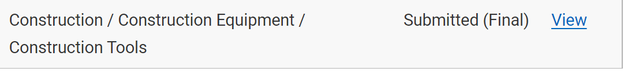

A final submission report will then be made available for triage and assessment by Subject Matter Expert individuals or groups the Administrator deems to be the best fit to assess your solution.

The identified assessors will review your solution and provide assessment feedback. They may also request further information. At all stages you will be informed of the progress of your solution by the Scotland Innovates Administrator.

Once the assessment process has concluded the Administrators will forward any assessment feedback to you, including any additional information relevant at the time, e.g., appropriate platforms, support or procurement opportunities and will close the solution submission. If there is an identified need or appetite for your solution, we may put you in contact with relevant bodies who may want to undertake initial trials in defined areas or support you to take your solution to market.

