

Regulatory Pathway for Medical Device Manufacturers

Elaine Gemmell

Document History

|  |  |  |
| --- | --- | --- |
| Version | Document Control | Summary of Changes |
| 1.0 | Not Applicable – Original Document | Not Applicable – Original Document |
|  |  |  |
|  |  |  |

Document Approval

|  |  |  |  |
| --- | --- | --- | --- |
|  | Name/Position | Signature | Date |
| Compiled | Elaine Gemmell  Head of Regulatory Affairs |  |  |
| Reviewed/Approved | Gillian Henderson  Head of Project Management |  |  |

## Contents

Scope 3

Purpose 3

Part A 4

Background 4

1. CE Mark /UKCA Mark 4

2. Post Brexit Implication for Medical Device Manufacturers 4

3. Regulatory Landscape 5

Regulatory Pathway 6

4. Definition of Medical Device 6

5. Classification 7

6. Conformity Assessment 11

7. Quality Management System 14

8. Essential Requirements 14

9. Design and Manufacture 15

10. Technical Documentation 16

Part B 17

Initiatives to Facilitate Market Access 17

11. Scottish UK Approved Body 18

12. Scientific Advice from the Regulators 18

13. Proof of concept 19

14. Patient and Public Involvement 19

15. Scotland-wide collaboration 19

16. Industry which supports Medical Device Development 19

17. Sterile Services and Sterilisation 19

18. Unique Device Identifier 20

19. Approval of Medical Devices for Use in NHS 20

20. Manufacturer 20

Conclusion 21

## Scope

This document will consider various medical device regulations that are available and used in Great Britain. For the approval of medical devices, Great Britain is considered to represent England, Scotland and Wales. For regulatory purposes, Northern Ireland will have different requirements as will the European Union territories and will be excluded from the scope of this positional paper.

Medical devices are generally classified as medical devices, software as a medical device, in-vitro diagnostic devices and active implantable devices. This paper will not consider combination devices or advanced therapeutic medical devices such as devices that use human tissue or plasma products. The current applicable legislation in Great Britain is [Medical Devices Regulations 2002](http://www.legislation.gov.uk/uksi/2002/618/contents/made)(SI 2002 No 618, as amended). No consideration has been given to future UK legislation which is currently subject to public consultation.

## Purpose

The purpose of this positional paper is to inform SHIP of the requirements for regulatory approval of medical devices and to consider how to respond to the requirements of medical device manufacturers regarding the process to place medical devices on the market in Great Britain.

It will also determine what initiatives may need to be considered to ensure that medical device manufacturers are fully supported and that Scotland is considered a centre of excellence for medical device innovation.

This document is set out in two sections.

Part A sets out information that is of importance to the manufacturer and outlines the process of regulatory approval. This is intended to inform medical device manufacturers of the regulatory requirements for placing medical devices on the market in Great Britain.

Part B sets out some suggestions for initiatives that, if implemented, would make Scotland a centre of excellence for medical device development.

# Part A

## Background

1. CE Mark /UKCA Mark

This is a mark which signifies compliance with EU/UK Directives which require specific standards of performance, quality, safety, and efficacy to be met.

The manufacturer of a medical device is expected to design and manufacture a product that is safe and effective throughout its life-cycle.

In Great Britain, medical devices are currently regulated under

* [Directive 90/385/EEC](https://eur-lex.europa.eu/legal-content/EN/TXT/HTML/?uri=CELEX:31990L0385&from=EN) on active implantable medical devices (EU AIMDD)
* [Directive 93/42/EEC](https://eur-lex.europa.eu/legal-content/EN/TXT/?uri=CELEX:31993L0042) on medical devices (EU MDD)
* [Directive 98/79/EC](https://eur-lex.europa.eu/legal-content/EN/TXT/HTML/?uri=CELEX:31998L0079&from=EN) on in vitro diagnostic medical devices (EU IVDD)

These directives are given effect in UK law through the [Medical Devices Regulations 2002](http://www.legislation.gov.uk/uksi/2002/618/contents/made) (SI 2002 No 618, as amended) (UK MDR 2002).

In Europe, medical devices are currently regulated under

* Regulation (EU) 2017/745 on Medical Devices
* Regulation (EU) 2017/746 on In Vitro Diagnostic Medical Devices

These regulations are a legal act of the [European Union](https://en.wikipedia.org/wiki/European_Union) that becomes immediately enforceable as law in all [member states](https://en.wikipedia.org/wiki/Member_state_of_the_European_Union) simultaneously and do not need to be transposed into national law.

The legislation sets out fundamental design and manufacturing requirements that provide assurance that a medical device is safe and performs as intended by the manufacturer. In the Directives, these are known as Essential Requirements (ER) and in the Regulations these are referred to as General Safety and Performance Requirements (GSPR).

1. Post Brexit Implication for Medical Device Manufacturers

The Medicines and Healthcare products Regulatory Agency (MHRA) is the **competent authority** in the UK.

An **approved body**, previously referred to as notified body, is an organisation that has been designated by the MHRA to assess whether manufacturers and their medical devices meet the requirements set out in the Medical Devices Regulations 2002 (SI 2002 No 618, as amended) (UK MDR 2002).

For medical devices that require assessment as part of the conformity assessment route, manufacturers apply to a UK approved body. For details of conformity assessment refer to section 6. Following an appropriate assessment, the approved body will issue relevant certification allowing manufacturers to place UKCA marking on their products and place them on the market in Great Britain.

The UKCA mark has been available for use in Great Britain from 1 January 2021 although CE marking will continue to be required for devices placed on the Northern Ireland market and EU rules will need to be met. CE marked devices will also be accepted on the Great Britain market until 30 June 2023.

To place a CE mark on a medical device for circulation in both Northern Ireland and the EU, manufacturers must use an EU-recognised and domiciled notified body to undertake any mandatory third-party conformity assessment. The results of conformity assessments carried out by UK notified bodies will not be recognised within the EU.

Designated UK Notified Bodies appointed by MHRA will be able to conduct conformity assessments for the purposes of the Northern Ireland market alone. For these products, in addition to the CE marking, device manufacturers will also need to apply the UKNI marking. These products cannot circulate on the EU market.

CE certificates issued previously by UK Notified Bodies before 1 January 2021 will remain valid for the GB Market until 30 June 2023. If there is a change or update to the device, the relevant UK approved body will need to issue a new UKCA certificate to replace the CE certificate.

The following organisations are currently designated to do conformity assessment in Great Britain.

BSI Assurance UK Ltd (0086)

Designation: Medical Device Active Implantable Medical Devices, In-vitro Diagnostics Medical Devices

SGS United Kingdom Ltd (0120)

Designation: Medical Device, In-vitro Diagnostics Medical Devices

UL International (UK) Ltd (0843)

In-vitro Diagnostics Medical Devices

1. 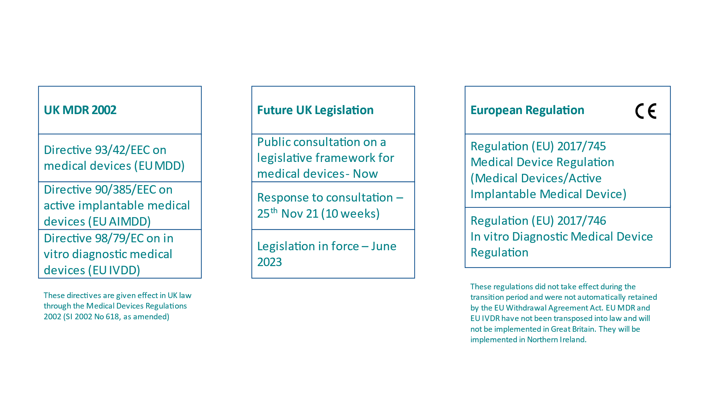Regulatory Landscape

## Regulatory Pathway

Figure 1: Regulatory Pathway

1. Definition of Medical Device

According to 93/42/EEC Article;

“**medical device**” means any instrument, apparatus, appliance, software, material or other article, whether used alone or in combination, including the software intended by its manufacturer to be used specifically for diagnostic and/or therapeutic purposes and necessary for its proper application, intended by the manufacturer to be used for human beings for the purpose of:

* diagnosis, prevention, monitoring, treatment or alleviation of disease,
* diagnosis, monitoring, treatment, alleviation of or compensation for an injury or handicap,
* investigation, replacement or modification of the anatomy or of a physiological process,
* control of conception,

and which does not achieve its principal intended action in or on the human body by pharmacological, immunological or metabolic means, but which may be assisted in its function by such means.

**“in vitro diagnostic medical device”** means any medical device which is a reagent, reagent product, calibrator, control material, kit, instrument, apparatus, equipment or system, whether used alone or in combination, intended by the manufacturer to be used in vitro for the examination of specimens, including blood and tissue donations, derived from the human body, solely or principally for the purpose of providing information:

* concerning a physiological or pathological state, or
* concerning a congenital abnormality, or
* to determine the safety and compatibility with potential recipients, or
* to monitor therapeutic measures.

If the manufacturer intends to develop a product which satisfies one of the definitions above, it will be a medical device and will be regulated under the appropriate medical device legislation.

1. Classification

The classification of medical devices is a ‘risk based’ system based on the vulnerability of the human body, taking account of the potential risks associated with the devices. This approach uses classification rules which are set out in Annex IX of Directive 93/42/EEC.

Although these rules will adequately classify devices, a small number of products may be more difficult to classify. Such cases include devices which are borderline cases between two different classes of medical devices.

The classification rules are based on criteria such as duration of contact with the patient, degree of invasiveness and the part of the body affected by the use of the device.

For the purpose of classification, the following terms are used:

1. **Duration**

Transient - intended for continuous use for less than 60 minutes.

Short term - intended for continuous use for not more than 30 days.

Long term - intended for continuous use for more than 30 days.

Note: continuous use means “an uninterrupted actual use of the device for the intended purpose. However where usage of a device is discontinued in order for the device to be replaced immediately by the same or an identical device this shall be considered as an extension of the continuous use of the device”

1. **Invasiveness**

Invasive devices - a device which, in whole or in part, penetrates inside the body, either through a body orifice or through the surface of the body.

Body orifice - any natural opening in the body, as well as the external surface of the eyeball, or any permanent artificial opening, such as a stoma.

Surgically invasive device - an invasive device which penetrates inside the body through the surface of the body, with the aid of or in the context of a surgical operation. This may be considered an artificially created opening.

Note: A surgically created stoma is considered to be a body orifice therefore devices introduced into a stoma are not surgically invasive.

1. **Reusable surgical instrument** - Instrument intended for surgical use by cutting, drilling, sawing, scratching, scraping, clamping, retracting, clipping or similar procedures, without connection to an active medical device which can be reused after appropriate procedures have been carried out.
2. **Implantable device** - any device which is intended to be totally introduced into the human body or replace an epithelial surface or the surface of the eye by surgical intervention which is intended to remain in place after the procedure. Any device partially introduced into the human body through surgical intervention intended to remain in place for at least 30 days is also considered an implantable device.
3. **Active medical devices** - any medical device which depends on a source of electrical energy or any source of power other than that directly generated by the human body or gravity.

Standalone software is considered to be an active medical device.

Classification Rules

Rules 1-4 Non Invasive Devices

Rules 5-8 Invasive Devices

Rules 9-12 Active Devices

Rules 13-18 Special Rules

Figure 2: Classification of medical devices

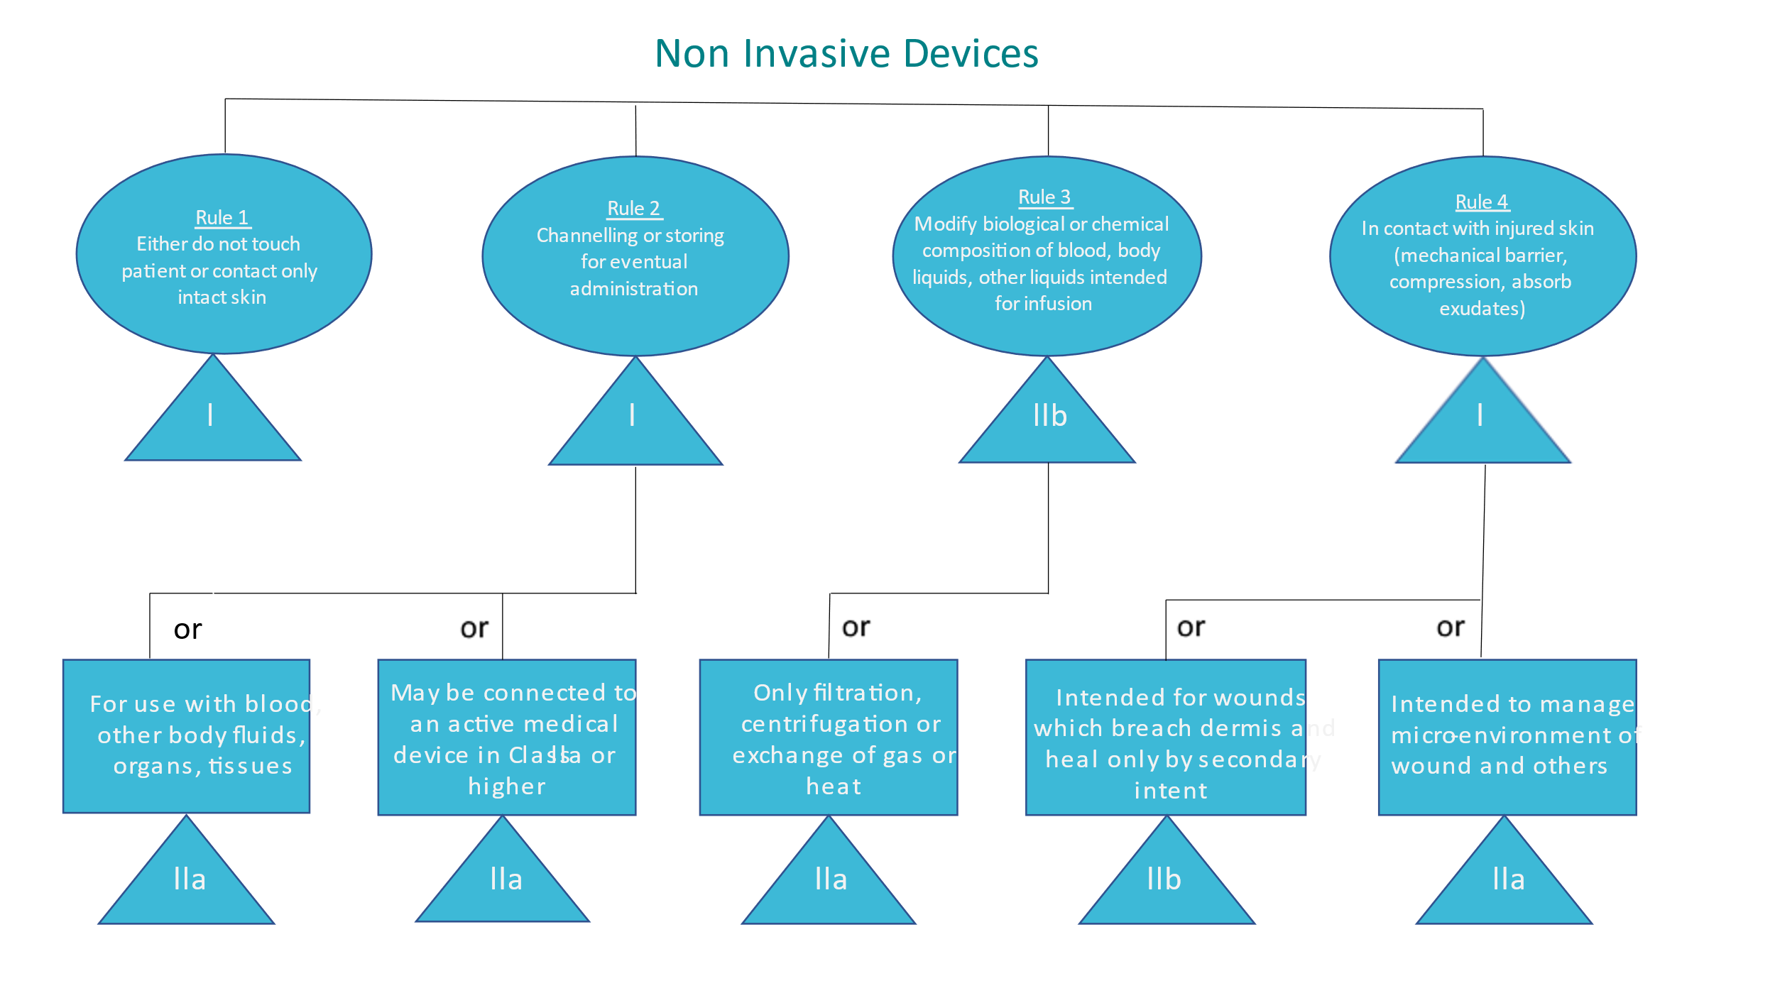

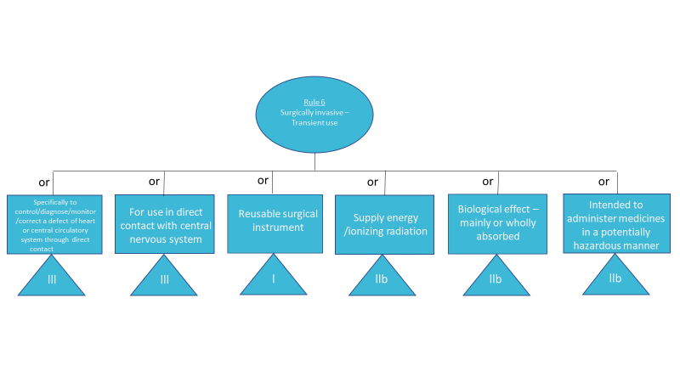

Where more than one classification category applies, the highest device classification will apply.

1. Conformity Assessment

Depending on the classification of the device there are a number of conformity assessment routes which can be used for the regulation of the device. These are outlined in 93/42/EEC, Article 11 and documented in the associated Annexes of the medical device directive.

For class I devices (non-sterile and without measuring function), **the manufacturer** is responsible for ensuring that products comply with the legal requirements. The manufacturer will compile a **technical file** with evidence of conformity and will sign a Declaration of Conformity. A UKCA mark is applied by the manufacturer and the device is registered with MHRA.

Where a Class I medical device is sterile or has a measuring function, assessment by a UK approved body is required for the functions relating to sterility or metrology

The assessment route for devices with a classification higher than class I chosen by most manufacturers is the full quality assurance system (Annex II). The notified body reviews the technical documentation according to the regulatory requirements in the directives and the quality management system ([ISO 13485](https://decomplix.com/about-us/)). After a successful audit, the notified body issues two certificates - the QMS certificate and the CE certificate. Annual surveillance audits are conducted thereafter by the notified body.

The following medical devices require an assessment and periodic review by a notified body:

Class I sterile medical devices (Is)

Class I medical devices with measuring function (Im)

Class IIa, IIb and III medical devices

Products assessed by a notified body are marked with a UKCA mark and the identification number of the responsible notified body.

## Quality Management System

Although there are many quality management systems**, ISO 13485** is specifically written to address the particular requirements of the medical device legislation. It is an international harmonised standard that sets out specific requirements for a quality management system which provides an organisation with the framework to demonstrate its ability to provide medical devices that consistently meet applicable regulatory requirements. The standard will cover all stages of the medical device lifecycle including design and development, production, storage, distribution, installation or servicing and post-market activities.

1. Essential Requirements

Medical Devices must meet the **essential requirements** set out in Annex I of Directive 93/42/EEC which apply to them, taking account of the intended purpose of the devices concerned.

Essential Requirements are fundamental design and manufacturing requirements that provide assurance that a medical device is safe and performs as intended by the manufacturer.

Depending on the particular medical device some of the Essential Requirements do not apply. In those cases, justifications should be provided for their exclusion.

Manufacturers will provide evidence that solutions have been adopted to meet the applicable Essential Requirements.

**Harmonised standards** may be used to demonstrate compliance with the requirements of the directive and provide a presumption of conformity.

The evidence of compliance will be documented in the technical file.

|  |  |
| --- | --- |
| Part 1 – General Requirements | |
|  | Risk Reduction and Acceptable Risk/Benefit |
|  | Safety and Risk Controls |
|  | Intended Performance |
|  | Lifetime of Device |
|  | Transportation and Storage |
|  | Side-effects must Constitute an Acceptable Risk |
| 6a. | Clinical Evaluation |
| Part 2 – Design and Construction | |
|  | Chemical, Physical and Biological Properties |
|  | Infection and Microbial Contamination |
|  | Construction and Environmental Properties |
|  | Devices with a Measuring Function |
|  | Protection Against Radiation |
|  | Devices with and Energy Source |
|  | Information Supplied by the Manufacturer |

Examples of Harmonised standards used to demonstrate compliance with the Medical Device Directive 93/42/EEC:

BS EN ISO 13485 - Medical devices - Quality management systems - Requirements for regulatory purposes

BS EN ISO 14971 - Medical devices - Application of risk

BS EN 1041 - Information supplied by the manufacturer of medical devices

BS EN 62304 - Medical device software - Software life-cycle processes

BS EN 62366-1 - Medical devices - Application of usability engineering

11. Design and Manufacture

Medical devices must be manufactured in accordance with stated methods of compliance with Essential Requirements. This may be achieved by the implementation of a 13485 quality management system. If the design and manufacture is sub-contracted, this may be achieved if the sub-contractors implement ISO13485 QMS. If this certification is not available in sub-contract organisations, the manufacturer must assume responsibility for ensuring compliance with requirements. This may be achieved by legal agreement which sets out requirements which must be met by the sub-contractor.

10. Technical Documentation

**The technical file** prepared by the manufacturer details all evidence of compliance with the medical device regulation. This technical file will be assessed by the notified body for devices with risk classification greater than Class I.

The technical file to support an application for regulatory approval under the medical device directive will include:

* General description of the product, including any variants planned and its intended use;
* Design specifications
* Standards which will be applied to fulfil essential requirements
* Results of risk analysis
* Design verification and validation
* Processes and systematic measures used in design cycle
* Preclinical and clinical evaluation
* Label and instructions for use

When implementing ISO 13485 quality management system, there is [also] a requirement for **a medical device file**. This will require similar information to be documented. The medical device file will document the following information:

* Description of the device
* Intended purpose
* Labelling (packaging, marking, instructions for use, installation and maintenance instructions)
* Device specification
* Specifications for its manufacture, packaging and storage
* Market surveillance
* Proof of conformity, including verification and validation

# Part B

## Initiatives to Facilitate Market Access

The following initiatives would be a very valuable asset to companies developing medical devices in Scotland.

* Fast Prototype Manufacturing Facilities
* Access to clinical test facilities
* Access to Quality Management consultancy resource
* Scottish based UK approved body
* Initial training in medical device regulatory pathway

Such organisations may also benefit from a central advisory resource which could offer advice and support for a range of activities such as

* Regulatory consultancy*
* Legal services
* IP consultancy
* Advice on sterilisation validation
* Biocompatibility
* Risk assessment
* Electrical safety and EMC testing
* Critical evaluation of data
* Quality Management Systems
* Internal and Supplier Audits
* Clinical trial and ethics applications

* A potential framework for quality and regulatory consultancy. This develops a model that each organisation can use but at the same time builds value in the organisation. Supporting R&D activities through alignment with section 7.3 (Design and Development) of ISO 13485

* Supporting generation of the regulatory documentation required for regulatory body approval
* Training and consultative support to train a competent Quality Management Representative (QMR) and/or Qualified Person (QP) at the organisation’s premises
* Coaching of the QMR to build and implement their own quality management system fit for their own needs.
* Support prior to stage 1 and 2 assessment for QMS for certification
* Review and feedback in relation to technical documentation prior to submission

In due course, as organisations gain experience this can be shared through the industry. This could be achieved by organising a ‘trade association’ or setting up a moderated on-line forum.

Medical device manufacturers may also benefit from shared amenities such as:

* Fast prototyping facilities
* 3D printing
* Biocompatibility Test Laboratories (UKAS 10993 series of standards)
* Electrical Safety and EMC Test Laboratories (UKAS 60601 series of standards)
* Material testing laboratories

11. Scottish UK Approved Body

The pre Brexit UK notified bodies were automatically designated as UK Approved Bodies under UK MDR 2002. MHRA has indicated that although it has not received any formal applications to become UK Approved Bodies for medical devices, they have had “significant expressions of interest”. The small number of UK Approved Bodies currently has resulted in delays for companies seeking conformity assessments. Anecdotally, the UK Approved Bodies will not be able to meet the UK demand for UKCA marks and large companies will be given preference over smaller companies. As a consequence, companies who wish to commercialise devices in Great Britain should approach their chosen UK Approved Body as early as possible to discuss submissions and address concerns.

Typical activities that can be undertaken by a UK Approved Body include:

* full quality assurance: an assessment of the manufacturer’s quality system, including design
* examination of design, assessing the full product design dossier
* assessment of technical information and perform appropriate sample testing of production
* verification of either every unit or every batch of product
* production and product quality assurance: assessment of either the manufacturer’s quality system covering production and inspection (production QA) or final inspection (product QA)
* conduct unannounced audits of manufacturers

It is not clear what criteria need to be satisfied to become a UK Approved Body, however, MHRA could be contacted for further information.

12. Scientific Advice from the Regulators

Access to regulators would be a significant benefit to organisations. In many instances a simple piece of advice from the regulator will save a great deal of time and increase confidence in the development pathway. MHRA has a mechanism to provide scientific advice for medicines and a consideration would be to mirror this service for medical devices. The process for medicines may be used as a template for this advice:

Advice can be requested at any stage of the initial development of the device.

Questions to be addressed would be submitted in advance and a meeting would be arranged.

It is possible to have a joint meeting with MHRA and National Institute for Clinical Excellence (NICE).

13. Proof of concept

Many medical device manufacturers will have an innovative concept to develop. At the start of the development process, it may not be obvious that the concept will work and that it will be an acceptable solution for healthcare providers. As the cost of regulation may be significant in terms of resource, it would be useful to have a small proof of concept fund. This would allow proof of concept prototypes to be developed which will be used to inform the development of the device. A small change in intended use may have a significant impact on the classification of the device and the appropriate conformity assessment route.

14. Patient and Public Involvement

Many aspects of medical device development will benefit from patient and public involvement (PPI). In this instance public can refer to patients, potential patients, carers and people who use health and social care services in addition to organisations that represent services users. While this is not a requirement for regulation, the design process will be enhanced by PPI particularly for usability, risk assessment and instructions for use.

Access to appropriate PPI groups would be a significant advantage to medical device manufacturers.

15. Scotland-wide collaboration

Experience gained in regulation of medical devices could be shared making Scotland an informed and collaborative base for medical device manufacture. A supportive regulatory group could be set up as a central resource. This could be accessed virtually and a repository of up to date information and current experience with the approved body or regulator could be shared by way of either case studies or forum. This would be managed and moderated with opportunities to signpost manufacturers to get appropriate advice.

16. Industry which supports Medical Device Development

There is good manufacturing capability within Scotland for contract manufacture services that may be required in medical device development. These industries may be focussed on non-medical device development. Examples may be plastic manufacturers with plastic moulding capability, electronic sub-assembly manufacturers, packing organisations or metal workshops. This expertise would be ideal to use in medical device manufacture. If these non-medical device organisations were given assistance to implement an ISO 13485 compliant quality management system this would make the available workforce available in Scotland more attractive. A secondary benefit would be to make these organisations more attractive tol foreign medical device manufacturers.

17. Sterile Services and Sterilisation

A key component of developing medical devices is producing product that can be cleaned, disinfected or sterilised. A medical device manufacturer is expected to produce validated procedures to do this. Access to sterile service organisations would provide a means to validate these protocols.

If these services could be linked to NHS, this would inform the manufacturers of current practice. This would be invaluable as it is highly unlikely that an NHS organisation would deviate from standard practice.

18. Unique Device Identifier

Unique Device Identifier (UDI) is a system of identification for medical devices throughout the lifetime of the product. This is a key component of traceability if medical devices essential for vigilance. It would be useful to have a central resource that can assist in the procurement and application of UDI.

19. Approval of Medical Devices for Use in NHS

At present it is unclear to industry how medical devices can be adopted in the NHS. If a joint industry/NHS group was established to advise on the requirements for approval in the NHS this would be a huge advantage. This should be available at the outset of the projects as it may have a significant impact on specification and design but should also be available at the conclusion of the project to assist in adoption.

20. Manufacturer

93/42/EEC, Article 1 defines the manufacturer as the natural or legal person with responsibility for the design, manufacture, packaging and labelling of a device before it is placed on the market under his own name, regardless of whether these operations are carried out by that person himself or on his behalf by a third party. The obligations of this Directive to be met by manufacturers also apply to the natural or legal person who assembles, packages, processes, fully refurbishes and/or labels one or more ready-made products and/or assigns to them their intended purpose as a device with a view to their being placed on the market under his own name.

This means the design or manufacture of a medical device may be carried out by an organisation that is different from the manufacturer. The manufacturer may assume responsibility to ensure that these functions are performed in accordance with the applicable legislation.

Consideration could be given to a central department which can assume responsibility as a manufacturer. This would carry a considerable liability risk and consequent resource requirement and as such would be required to exercise considerable control over design and manufacture of the medical devices. The devices would be marketed under the name of the manufacturer.

**ELAINE GEMMELL**

Head of Regulatory Affairs

Email: elaine.gemmell@innoscot.com