**NHS Scotland Innovation Fellowship Scheme**

The Innovation Fellowship Scheme was launched in May 2022. It aims to strengthen the innovation culture to solve real problems in the NHS and social care, improving the quality, efficiency and sustainability of health and care delivery and supporting NHS Scotland’s Recovery Plan.

Following a thorough and highly competitive application process, nine posts have been awarded in the first cohort of the scheme. The successful applicants and their projects are provided below.

**North Region**

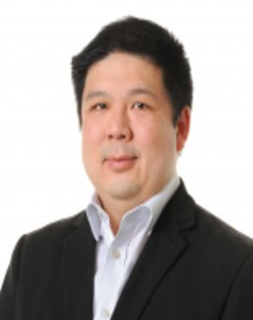**Gerald Lip** - *The application of artificial intelligence in breast cancer detection in the clinical environment.*

Dr Lip will be engaging in a prospective evaluation of working alongside artificial intelligence (AI) in an NHS Grampian breast screening project called GEMINI. This will be a significant precursor study to evaluate and facilitate the adoption of AI into the UK screening workflow. He will also be involved in further imaging-based AI projects in the North of Scotland with the aim of finding an innovation led approach to early adoption of promising technology.

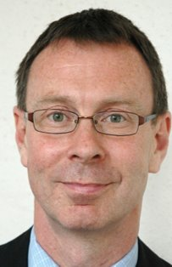**Andrew Radley** - *Community Pharmacy HbA1C Point-of-Care testing for early identification of individuals with pre-diabetes for intervention.*

Andrew is a Board and Honorary Reader at University of Dundee. His current areas of research activity are centred on harnessing the role of community pharmacy to improve population health. Current projects involve the early diagnosis of cancer; reducing drug-related deaths; and identifying people with pre-diabetes. Andrew participates in the work of the Liver Research Group at the University of Dundee. His PhD focussed on designing and evaluating a complex public health intervention for treating hepatitis C.

Andrew is thrilled to have been successful in gaining an Innovation Fellowship with the Scottish Health and Industry Partnership. He plans to use the opportunity to develop a community pharmacy infrastructure within the four participating boards and expand the numbers of people at high risk of developing type two diabetes who are engaged in weight management interventions.

**Priti Singh** - *Digital Integration and visibility of Unscheduled Community care in Adult Mental Health: Crisis pathways and Suicide Prevention.*

Dr. Singh earned her medical degree from India and subsequently trained in Scotland and Northern Ireland to complete specialist training in mental health. She also completed a Postgraduate Diploma in Interprofessional Health Care Management with distinction from Queens University, Belfast. Dr. Singh has been a Consultant Psychiatrist from 2012 and has been in a role as Consultant Psychiatrist in NHS Grampian since 2017. She has been serving as the Trainee Programme Director for North of Scotland General Adult psychiatry, Unit Clinical Director for Adult Mental services since 2020 and has been recently awarded the Fellowship of the Royal college of Psychiatrists.

Along with the North Regional Testbed and commercial partners, Dr.Singh aims to develop innovative technological solution that improve the digital connectivity and visibility of unscheduled mental health services across all tiers of health and social care.

The Artificial Intelligence assisted platform has the potential to provide relevant information on live service-user contacts with the health, social care and public protection organisational universe including primary care, third sector organisations, public protection agencies, A&E and secondary care specialist mental health services. The platform will use smart technologies to identify high risk clinical cases and aims to guide all tiers of services in integrating appropriate interventions including developing a ‘Single Safety Plan’.

The grand ambition is to integrate all tiers of unscheduled care for a seamless service user centric experience and ensuring there is ‘no wrong door’ access to high quality evidence-based care.

**South East Region**

**Joyce Henderson** - *Improving Developmental Dysplasia of the hip (DDH) surveillance Clinical validation of AI powered diagnostic portable ultrasound scanner for novice users.*

Joyce states "She's delighted to be awarded one of the first NHS Scotland Innovation Fellowships. I am particularly pleased as an AHP that I have been given this opportunity to work with world leading experts within industry and academia. Supported by Health Innovation South East Scotland, SHIP and NHS Fife Research, Innovation and Knowledge team, I will lead on an innovation project which aims to enhance diagnostic capabilities, improve patient outcomes, as well as develop efficient, effective clinical pathways which are not only sustainable but fit for the future needs of our population. This fellowship is an exciting development within NHS Scotland and a clear sign that Scotland is ready and willing to develop and be early adopters of the latest technical advancements. It also demonstrates that there is strong commitment to developing and supporting all NHS staff as innovators “

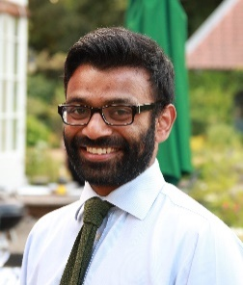***Rishi Ramaesh*** - *Catching it Early: Artificial Intelligence and Cancer Diagnostics”.*

Artificial intelligence within medical imaging is an exciting and fast-paced area of innovation and has the potential to revolutionise healthcare diagnostics. However, much more work and study is needed to ensure that AI tools are effective and safe to use in radiology. This project will mainly focus on using AI in cancer imaging and build on some of the existing collaboration between industry partners, academia and the health service. Two areas of development which are particularly exciting and innovative are in how we can utilise machine learning to detect lung cancer earlier and how we can use machine learning and radiomic analysis to personalise cancer treatments for patients. ​

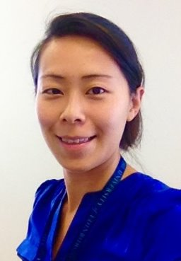**Yvonne Chun** - *Care Calendar, a digital innovation to achieve high-quality and sustainable health care journeys.​*

Dr Chun will focus on the pilot evaluation of Care Calendar—an interactive digital calendar designed to be used by clinical staff, patients and clinical managers. Using the Care Calendar, clinicians can tailor care pathways to ensure patients receive the right care at the right time, every time. Patients will be empowered in their own healthcare journey and clinical managers can utilise the data insights generated by Care Calendar to guide day-to-day running of the health service and service improvement.​

**West Region**

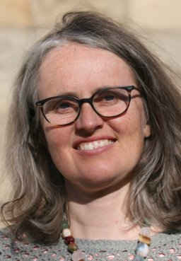**Ana Talbot** *- Preventative/ Proactive Technological Approaches to Frailty, Falls and Syncope*

Ana Talbot is a Consultant in Older Peoples Medicine based at University Hospital Monklands in NHS Lanarkshire and has an interest in a preventative and proactive approaches for people living with frailty.   She and colleagues have developed an award winning primary care frailty multidisciplinary team and more recently care home MDT.  The innovation fellowship will allow her to build on that to use digital technology to provide supportive self-management to help older people reduce their risk of future falls.  This in turn will allow them to have fewer falls and spend more time in their own homes.  ​

‘I am delighted to have been given the opportunity of this Innovation fellowship. It will be a valuable source of support to allow colleagues and I to develop a digital self-management tool that can be used by older people who have fallen to reduce their risk of future falls. This will allow them to live independently in their own homes for longer.  In turn it will reduce demand on hard pressed care at home, Scottish Ambulance Service, emergency department and other health and social care teams.  In co creating this with companies in Scotland, we will support further employment in digital technology.’

​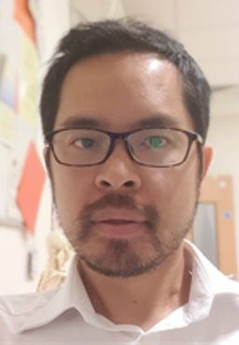**Steven Lo** - *1) 3D Telemedicine – a world first for Scotland: A Collaboration with Microsoft Corporation. 2) Augmented Reality Patient leaflets – bringing medicine to life.​*

Consultant Plastic Surgeon at Canniesburn Plastic Surgery Unit, Honorary Professor at the University of Glasgow and The Glasgow School of Art. Research collaborations with the School of Simulation and Visualisation at the Glasgow School of Art; West of Scotland NHS Innovations Hub; and Microsoft Research, Redmond, USA. These centre around digital innovations including the use of augmented reality in patient information leaflets to overcome the literacy gap, and the co-development with Microsoft of a novel form of 3D Telemedicine.​

**Chris Sainsbury** - *Developing and applying machine learning based tools for clinical benefit in Diabetes, Endocrinology and beyond.​*

“I trained in Diabetes & Endocrinology in Glasgow, and my MD was in the area of endothelial dysfunction in hypertension. More recently, my focus has been on analysis of datasets in the domain of diabetes and cardiovascular disease, including analysis of inpatient capillary blood glucose data, and the association between HbA1c variability and outcome in Type 1 diabetes.

My current research is largely focused on the application of machine learning methods to clinical problems, including the use of reinforcement learning, high-dimensional clustering and generative adversarial networks to predict clinical outcomes in diabetes using time series data, to investigate data-driven classification of diabetes subtypes from large datasets, and to tackle the general problem of clinical data sharing using synthetic datasets.”

[SHIP@gov.scot](mailto:SHIP@gov.scot)